ATAR Modern History

Unit 1: The French Revolution

***Assessment 1: Source Analysis***

Name: __________________________

**Source 1**

(*The Deficit* - Political cartoon by Isaac Cruikshank from 1788)

Translation Note:

Louis XVI: *Where are the funds?*Necker: *I left them there.*

Leaving through the “tax evaders” door

Aristocracy: *I have got them.*

Cleric: *I’ve got the rest.*

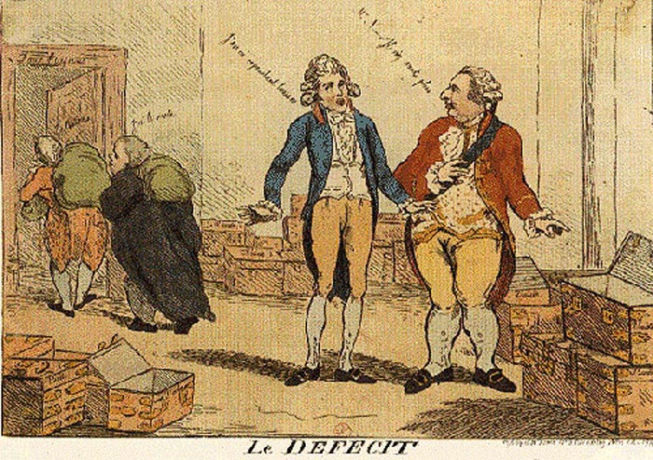

**Source 2**

(Extract from *Causes of the Revolution* accessed at: <http://apworldhistory2012-2013.weebly.com/causes-of-the-french-revolution.html>)

In a failed attempt for economic reform, Louis XVI decided to impose a new tax system. His tax reforms only increased the burden on the majority of France; the poor were heavily taxed while the aristocracy paid almost nothing. Jacques Necker was placed as finance minister in 1777, and his ideas that it was the government’s duty to make sure there was enough grain for the population soon increased his popularity among the people. Unfortunately, his proposals to restrict the power of the Ancien Regime made him unpopular with the king’s ministers, who later fired him.

**Source 3**

(Author unknown, 1970s caricature, *The Third Estate under the tax burden)*

Note: The text on the rock reads: *Taille, Impots and Corvées*

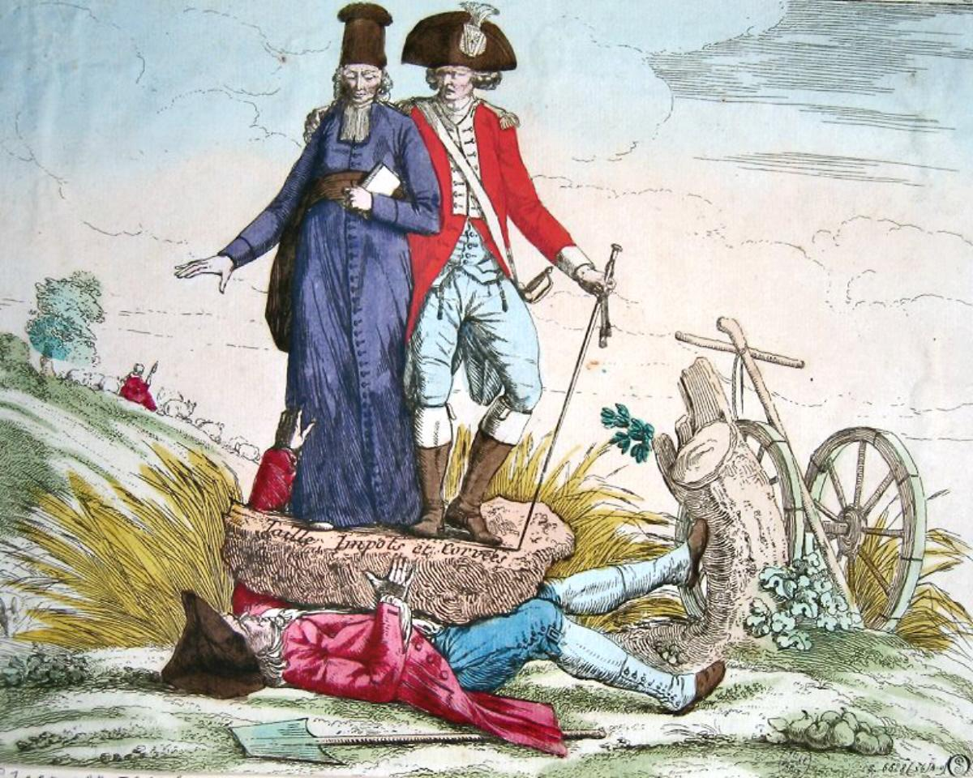

**Source 4**

(Soboul, A. (1977) *A Short History of the French Revolution*, University of California Press)

The bourgeoisie, the leading element in the Third Estate, now took over. Its aim was revolutionary: to destroy aristocratic privilege and to establish legal and civic equality in a society that would be no longer be composed of orders and constituted bodies. Nut the bourgeoisie intended to stay within the law. Before long, however, it was carried forward by the pressure of the masses, the real motive behind the revolution...